**STRUCTURED QUERY LANGUAGE**

1. Consider the following tables STORE and SUPPLIERS and answer the questions.

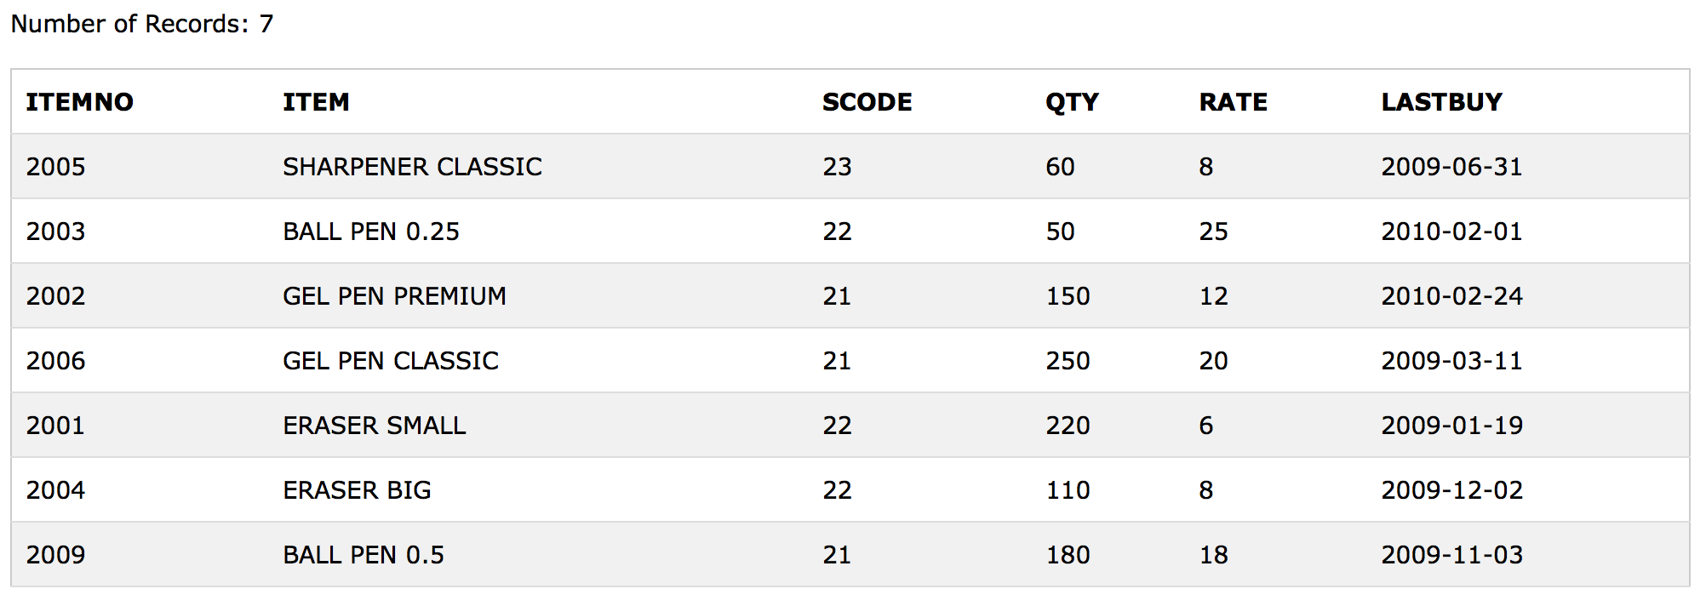**TABLE : STORE**

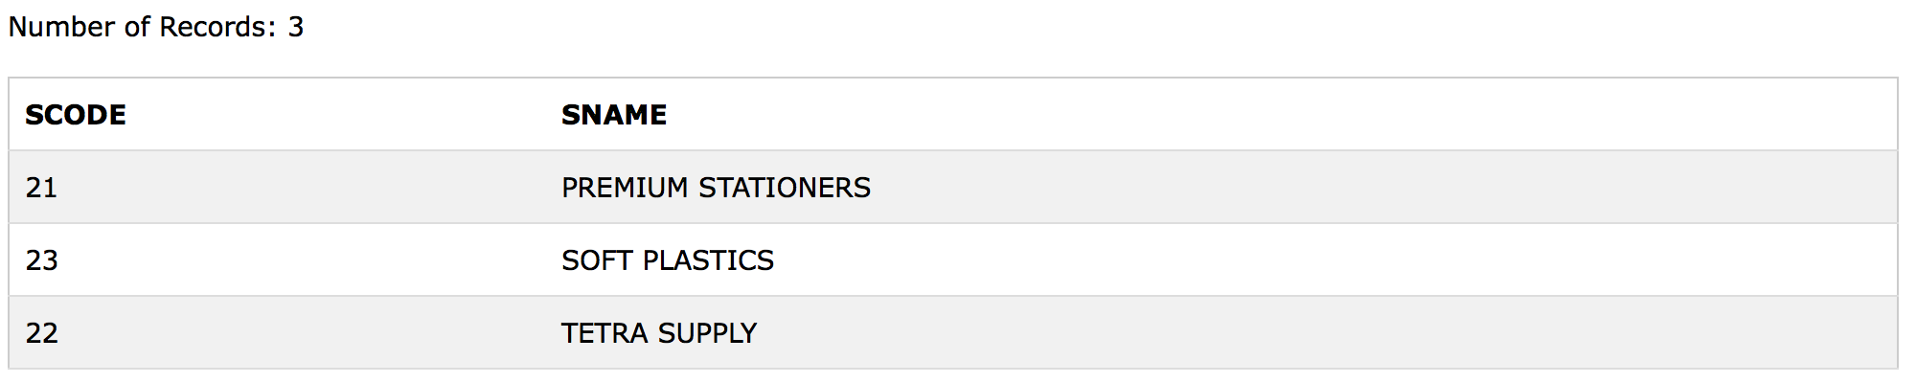**TABLE : SUPPLIERS**

1. To display the details of all the items in the Store table in ascending order of LastBuy.
2. To display the ItemNo and Item name of those items from Store table whose Rate is more than 15 Rupees.
3. To display the details of those items whose Suppliers code is 22 or Quantity in Store is more than 110 from the table Store.
4. To display the minimum rate of items for each supplier individually as per SCode from the table store.

**CREATING TABLES**

**STORE**

CREATE TABLE STORE (ITEMNO INTEGER NOT NULL PRIMARY KEY, ITEM VARCHAR(50) NOT NULL, SCODE INTEGER, QTY INTEGER, RATE INTEGER, LASTBUY DATETIME);

INSERT INTO STORE VALUES (2005, 'SHARPENER CLASSIC', 23, 60, 8, ‘2009-06-31');

INSERT INTO STORE VALUES (2003, 'BALL PEN 0.25', 22, 50, 25, ’2010-02-01’);

INSERT INTO STORE VALUES (2002, 'GEL PEN PREMIUM', 21, 150, 12, ’2010-02-24’);

INSERT INTO STORE VALUES (2006, 'GEL PEN CLASSIC', 21, 250, 20, ’2009-03-11’);

INSERT INTO STORE VALUES (2001, 'ERASER SMALL', 22, 220, 6, ‘2009-01-19’);

INSERT INTO STORE VALUES (2004, 'ERASER BIG', 22, 110, 8, ’2009-12-02’);

INSERT INTO STORE VALUES (2009, 'BALL PEN 0.5', 21, 180, 18, ’2009-11-

**SUPPLIERS**

CREATE TABLE SUPPLIERS (SCODE INTEGER NOT NULL, SNAME CHAR(20) NOT NULL);

INSERT INTO SUPPLIERS VALUES (21, 'PREMIUM STATIONERS’);

INSERT INTO SUPPLIERS VALUES (23, 'SOFT PLASTICS’);

INSERT INTO SUPPLIERS VALUES (22, 'TETRA SUPPLY’);

**ANSWERS**

i) SELECT * FROM STORE ORDER BY LASTBUY ASC;

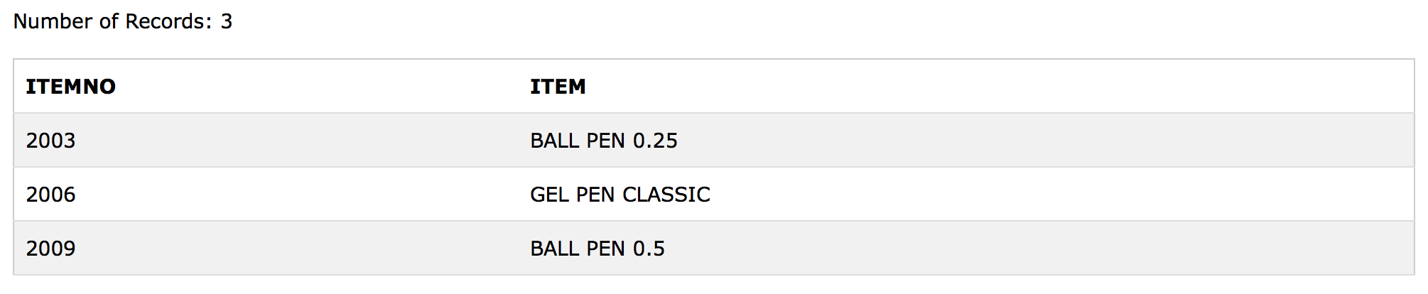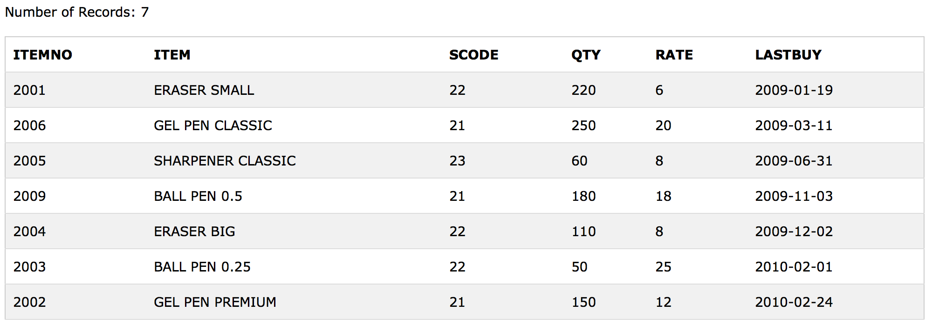

ii) SELECT ITEMNO, ITEM FROM STORE WHERE RATE>15;

iii) SELECT * FROM STORE WHERE SCODE=22 OR QTY>110;

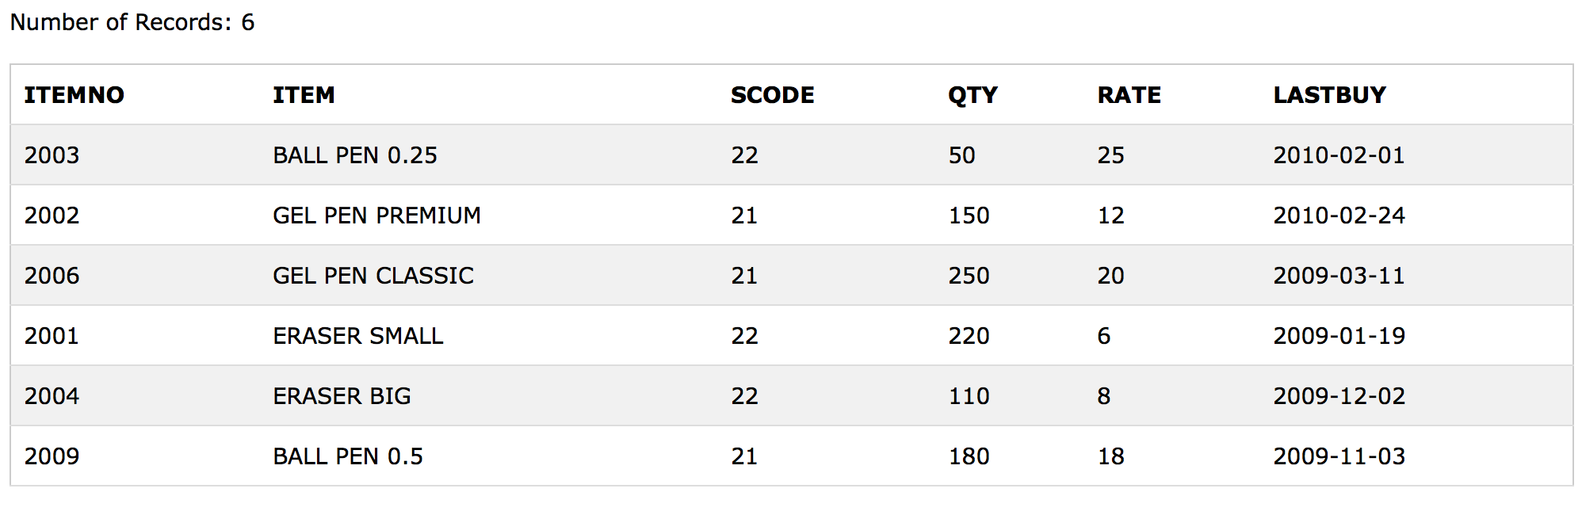iv) SELECT ITEM, SUPPLIERS.SCODE, SNAME, MIN(RATE) FROM STORE, SUPPLIERS WHERE SUPPLIERS.SCODE=STORE.SCODE GROUP 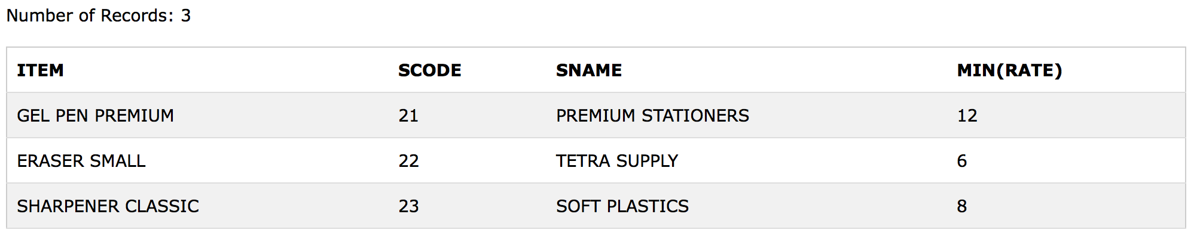BY STORE.SCODE;

1. Consider the following tables Item and Customer. Write SQL commands for the statement (i) to (iv).

**TABLE : ITEM**

| i_ID | ItemName | Manufacturer | Price |
| --- | --- | --- | --- |
| PC01 | Personal Computer | ABC | 35000 |
| LC05 | Laptop | ABC | 55000 |
| PC03 | Personal Computer | XYZ | 32000 |
| PC06 | Personal Computer | COMP | 37000 |
| LC03 | Laptop | PQR | 57000 |

**TABLE : CUSTOMER**

| C_ID | CustomerName | City | i_ID |
| --- | --- | --- | --- |
| 01 | N Roy | Delhi | LC03 |
| 06 | H Singh | Mumbai | PC03 |
| 12 | R Pandey | Delhi | PC06 |
| 15 | C Sharma | Delhi | LC03 |
| 16 | K Agarwal | Bangalore | PC01 |

1. To display the details of those customers whose city is Delhi.
2. To display the details of item whose price is in the range of 35000 to 55000 (both values included).
3. To display the customer name, city from table Customer, and ItemName and Price from table Item, with their corresponding i_ID.
4. To increase the price of all items by 1000 in the table Item.

**CREATING TABLES**

**CUSTOMER**

CREATE TABLE CUSTOMER (C_ID VARCHAR(10), CUSTOMERNAME CHAR(20), CITY CHAR (20), I_ID VARCHAR(10));

INSERT INTO CUSTOMER VALUES ('01', 'N ROY', 'DELHI', ‘LC03’);

INSERT INTO CUSTOMER VALUES ('06', 'H SINGH', 'MUMBAI', ‘PC03');

INSERT INTO CUSTOMER VALUES ('12', 'R PANDEY', 'DELHI', ‘PC06’);

INSERT INTO CUSTOMER VALUES ('15', 'C SHARMA', 'DELHI', ‘LC03');

INSERT INTO CUSTOMER VALUES ('16', 'K AGARWAL', 'BANGLORE', ‘PC01');

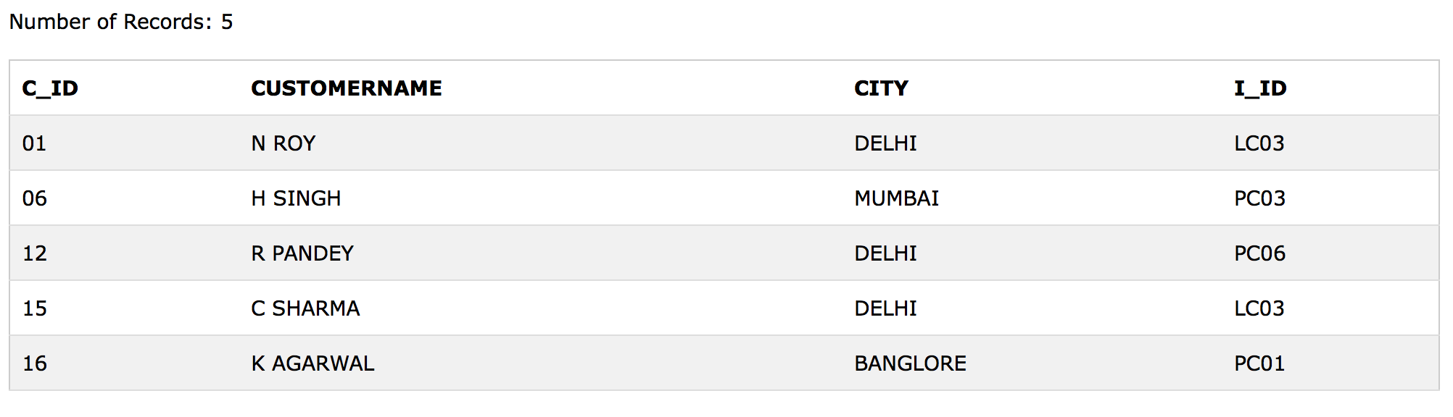

**ITEM**

CREATE TABLE ITEM (I_ID VARCHAR(10), ITEMNAME CHAR(20), MANUFACTURER CHAR (20), PRICE DECIMAL)

INSERT INTO ITEM VALUES ('PC01', 'PERSONAL COMPUTER', 'ABC', 35000)

INSERT INTO ITEM VALUES ('LC05', 'LAPTOP', 'ABC', 55000)

INSERT INTO ITEM VALUES ('PC03', 'PERSONAL COMPUTER', 'XYZ', 32000)

INSERT INTO ITEM VALUES ('PC06', 'PERSONAL COMPUTER', 'COMP', 37000)

INSERT INTO ITEM VALUES ('LC03', 'LAPTOP', 'PQR', 57000)

**ANSWERS**

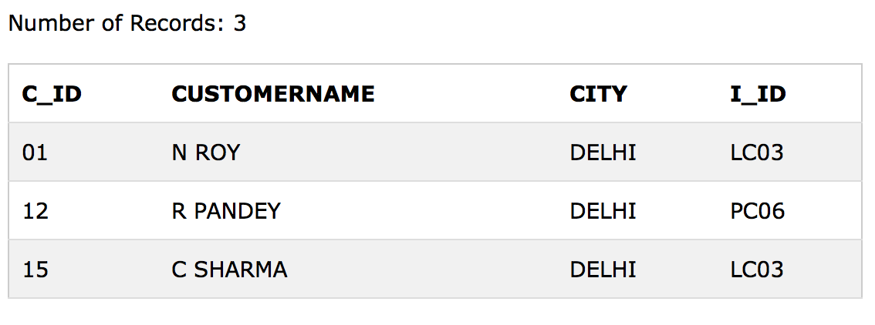

1. 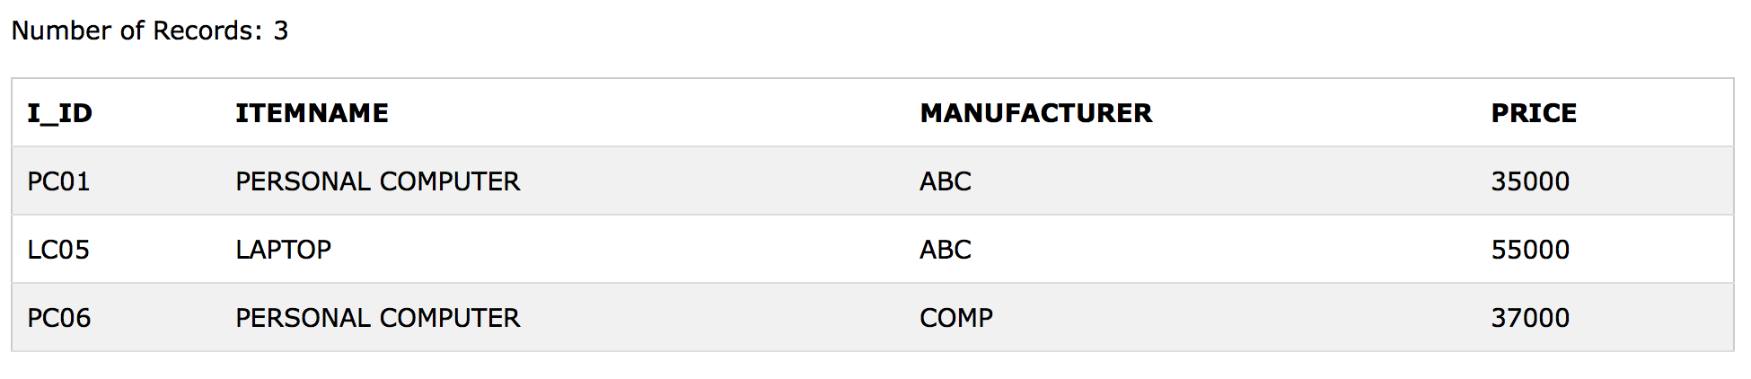SELECT * FROM CUSTOMER WHERE CITY=‘DELHI’;

ii) SELECT * FROM ITEM WHERE PRICE BETWEEN 35000 AND 55000;

1. SELECT CUSTOMERNAME, CITY, ITEMNAME, PRICE FROM 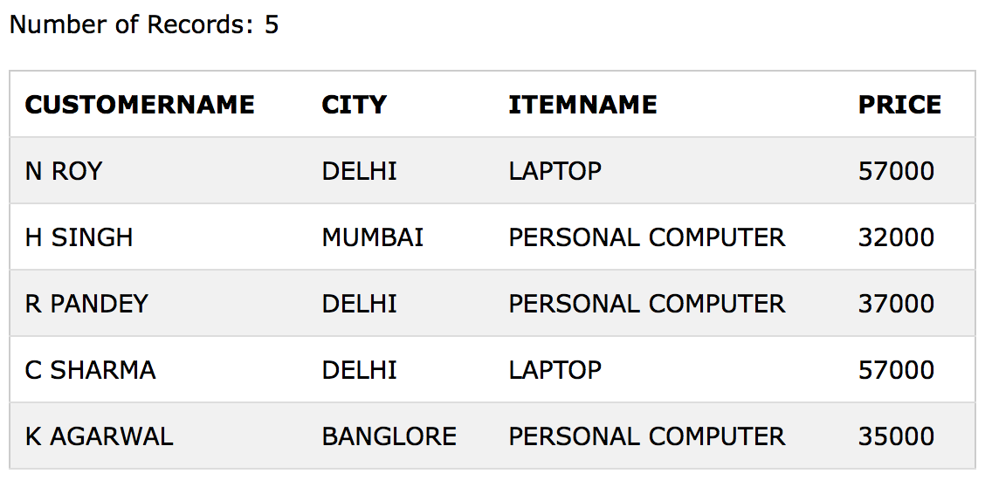CUSTOMER, ITEM WHERE CUSTOMER.I_ID=ITEM.I_ID;

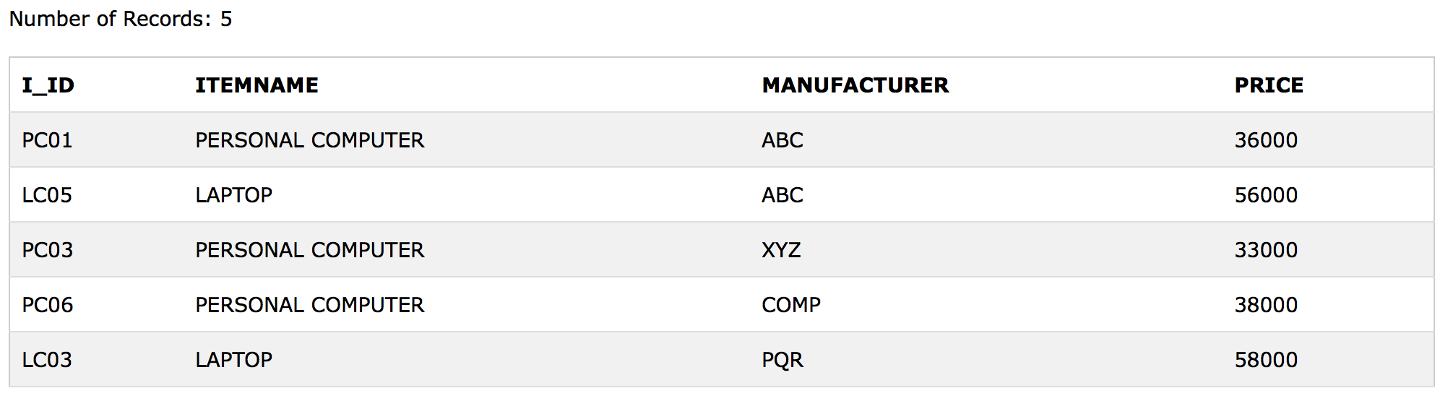iv) UPDATE ITEM SET PRICE=PRICE+1000;

**QUESTION 3**

Consider the following tables. Write SQL commands for the statement (i) to (iv).

**TABLE : SENDER**

**TABLE : RECIPIENT** 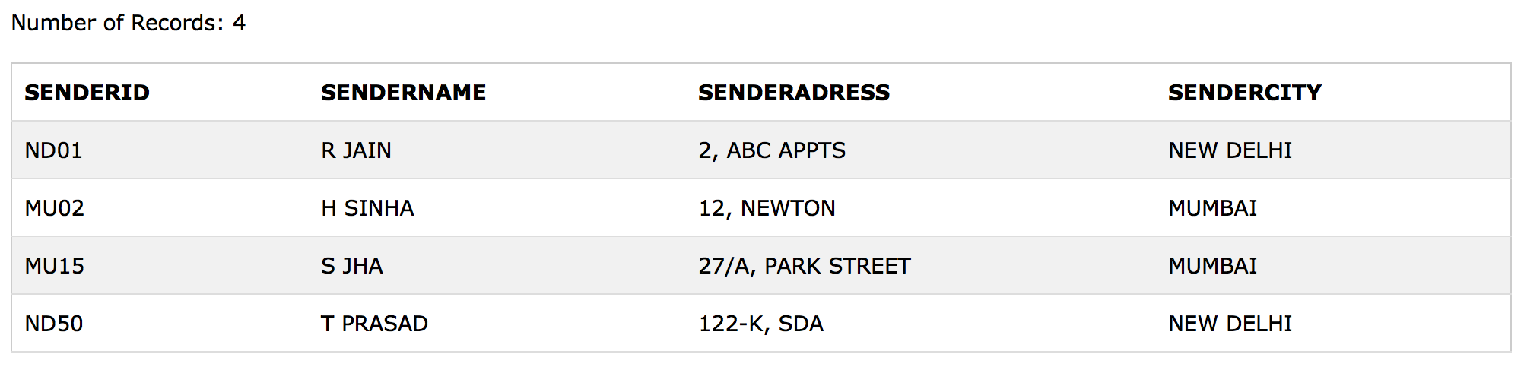

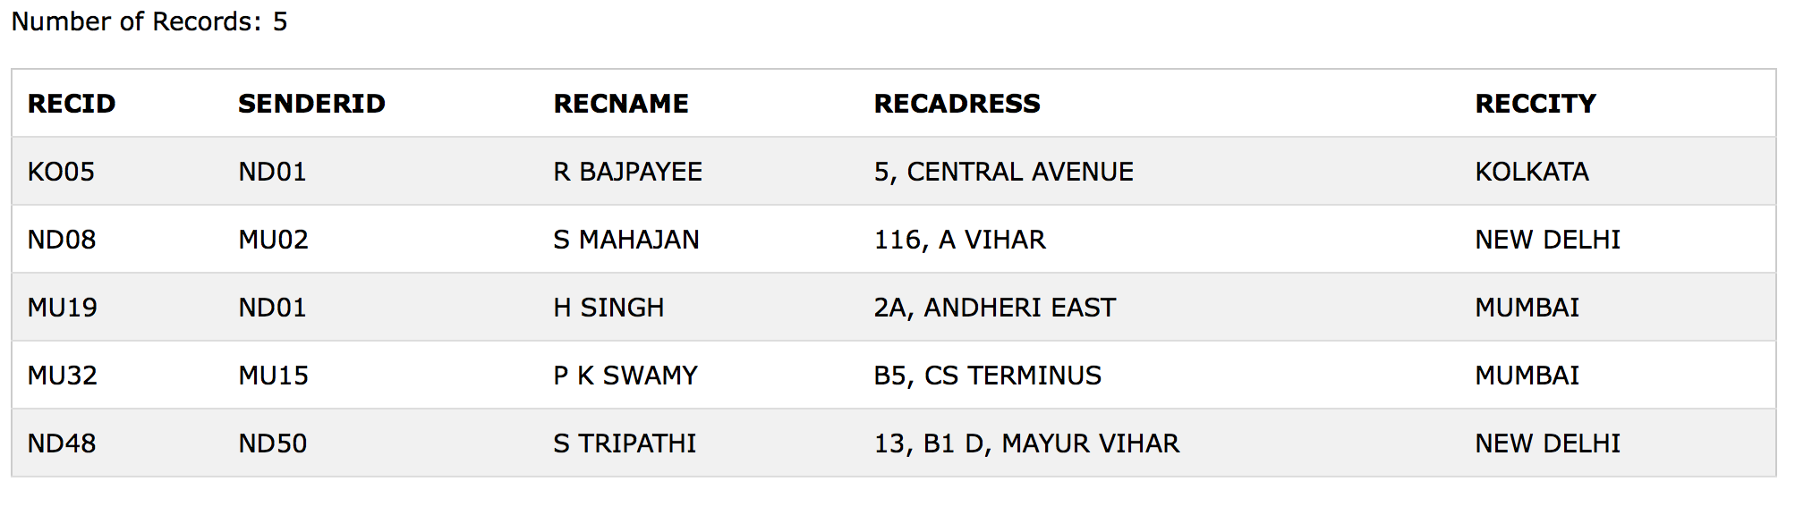

1. To display the names of all senders from Mumbai.
2. To display the RecID, sender name, sender address, RecName, RecAddress for every Recipient.
3. To display recipient details in ascending order of RecName.
4. To display the number of recipients from each city.

**CREATING TABLES**

**SENDER**

CREATE TABLE SENDER (SENDERID VARCHAR(10), SENDERNAME CHAR(20), SENDERADRESS CHAR(30), SENDERCITY CHAR(20));

INSERT INTO SENDER VALUES ('ND01', 'R JAIN', '2, ABC APPTS', 'NEW DELHI’);

INSERT INTO SENDER VALUES ('MU02', 'H SINHA', '12, NEWTON', ‘MUMBAI’);

INSERT INTO SENDER VALUES ('MU15', 'S JHA', '27/A, PARK STREET', 'MUMBAI');

INSERT INTO SENDER VALUES ('ND50', 'T PRASAD', '122-K, SDA', 'NEW DELHI’);

**RECIPIENT**

CREATE TABLE RECIPIENT (RECID VARCHAR(10), SENDERID VARCHAR(10), RECNAME CHAR(30), RECADRESS CHAR(30), RECCITY CHAR(10));

INSERT INTO RECIPIENT VALUES ('KO05', 'ND01', 'R BAJPAYEE', '5, CENTRAL AVENUE', ‘KOLKATA');

INSERT INTO RECIPIENT VALUES ('ND08', 'MU02', 'S MAHAJAN', '116, A VIHAR', 'NEW DELHI’);

INSERT INTO RECIPIENT VALUES ('MU19', 'ND01', 'H SINGH', '2A, ANDHERI EAST', ‘MUMBAI');

INSERT INTO RECIPIENT VALUES ('MU32', 'MU15', 'P K SWAMY', 'B5, CS TERMINUS', ‘MUMBAI');

INSERT INTO RECIPIENT VALUES ('ND48', 'ND50', 'S TRIPATHI', '13, B1 D, MAYUR VIHAR', 'NEW DELHI’);



**ANSWERS**

1. SELECT SENDERNAME FROM SENDER WHERE 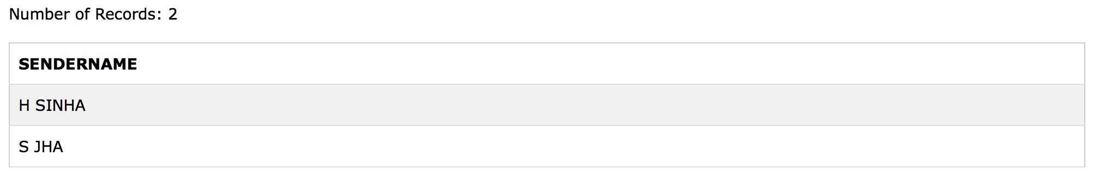SENDERCITY=‘MUMBAI’;
2. SELECT RECID, SENDERNAME, SENDERADRESS, RECNAME, RECADRESS FROM RECIPIENT, SENDER WHERE SENDER.SENDERID=RECIPIENT.SENDERID GROUP BY 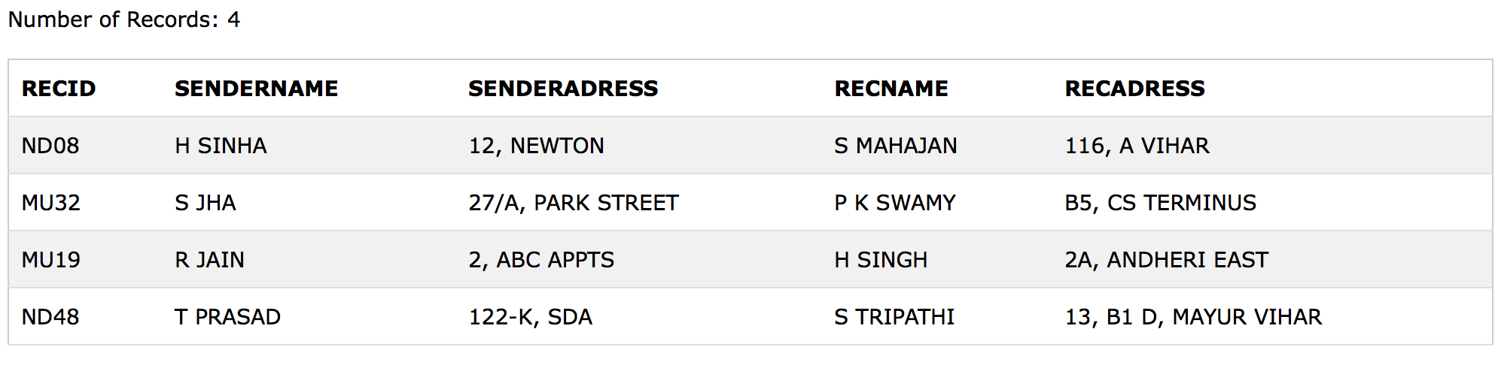SENDER.SENDERID;
3. 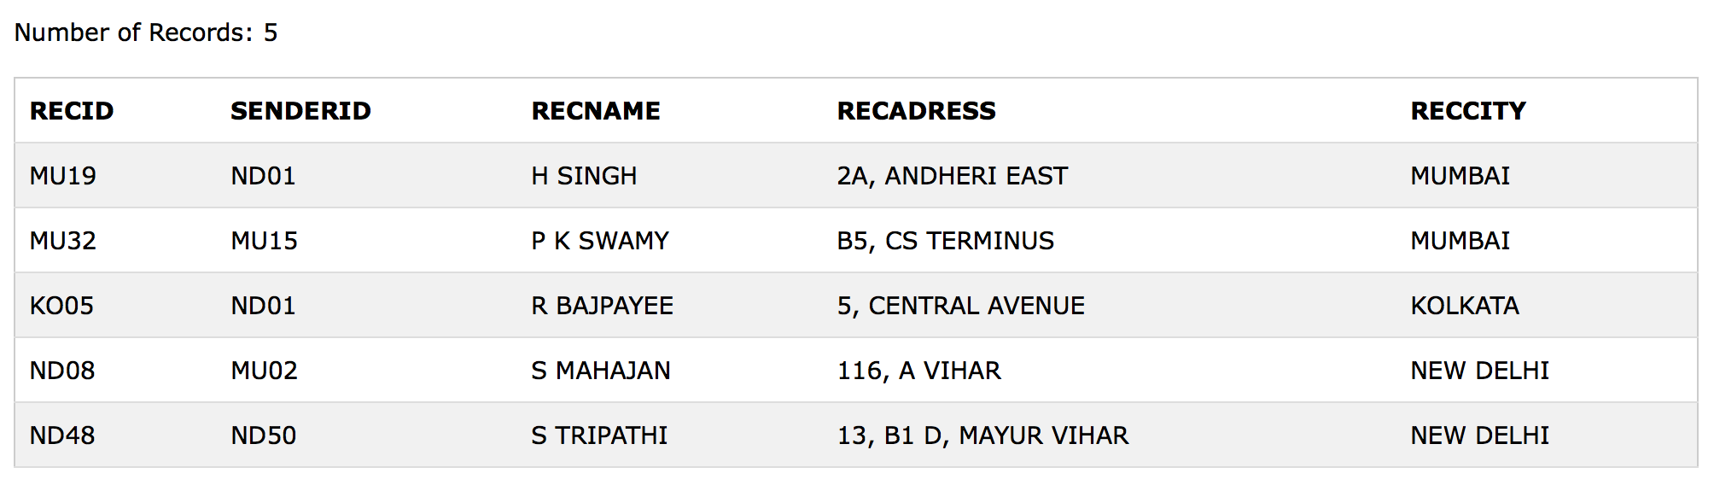SELECT * FROM RECIPIENT ORDER BY RECNAME ASC;
4. 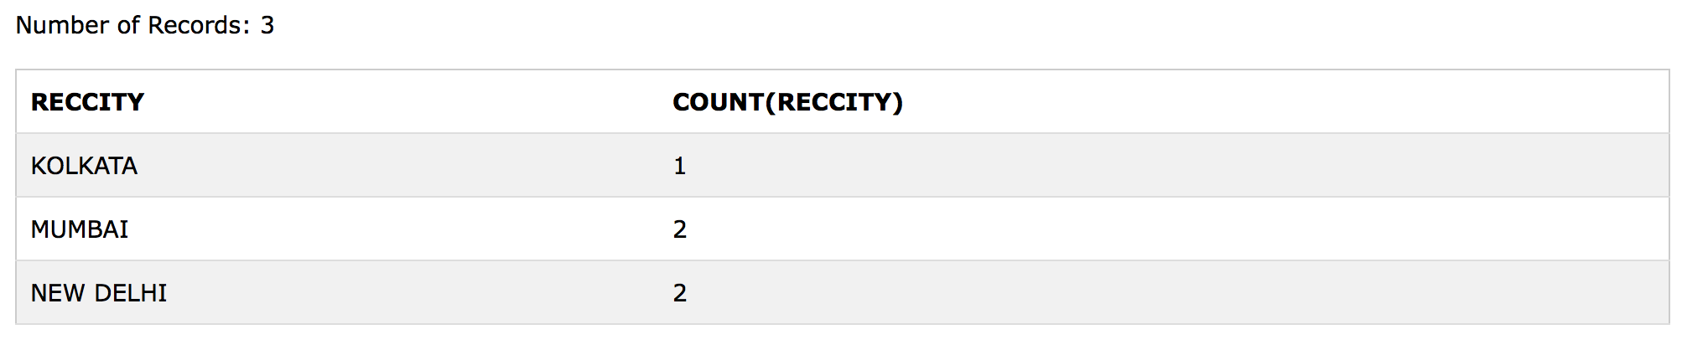SELECT DISTINCT RECCITY, COUNT(RECCITY) FROM RECIPIENT GROUP BY RECCITY;
5. 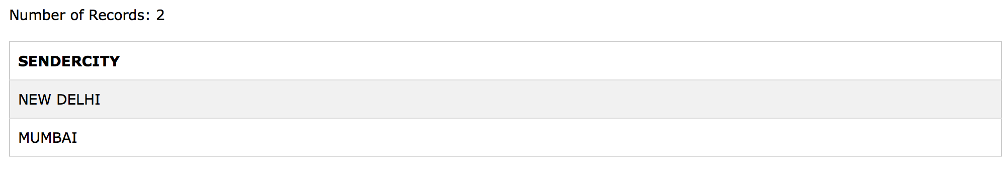SELECT DISTINCT SENDERCITY FROM SENDER;
6. SELECT A.SENDERNAME, B.RECNAME FROM SENDER A, RECIPIENT 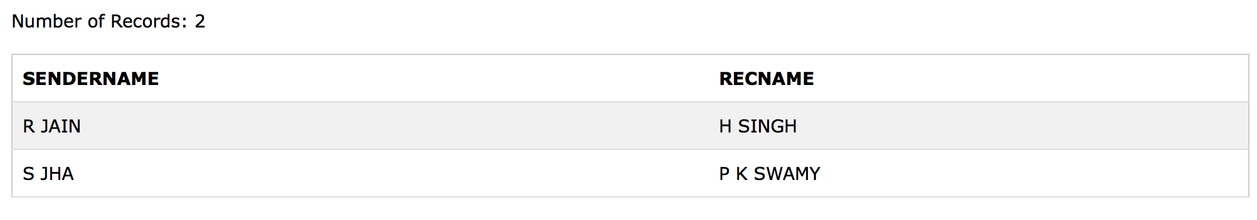B WHERE A.SENDERID=B.SENDERID AND B.RECCITY=‘MUMBAI’;

vii) SELECT RECNAME, RECADRESS FROM RECIPIENT WHERE 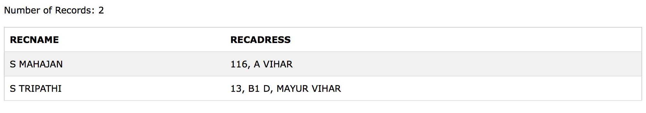RECCITY NOT IN ('MUMBAI', ‘KOLKATA');

viii) SELECT RECID, RECNAME FROM RECIPIENT WHERE SENDERID='MU02' OR SENDERID=‘ND50';

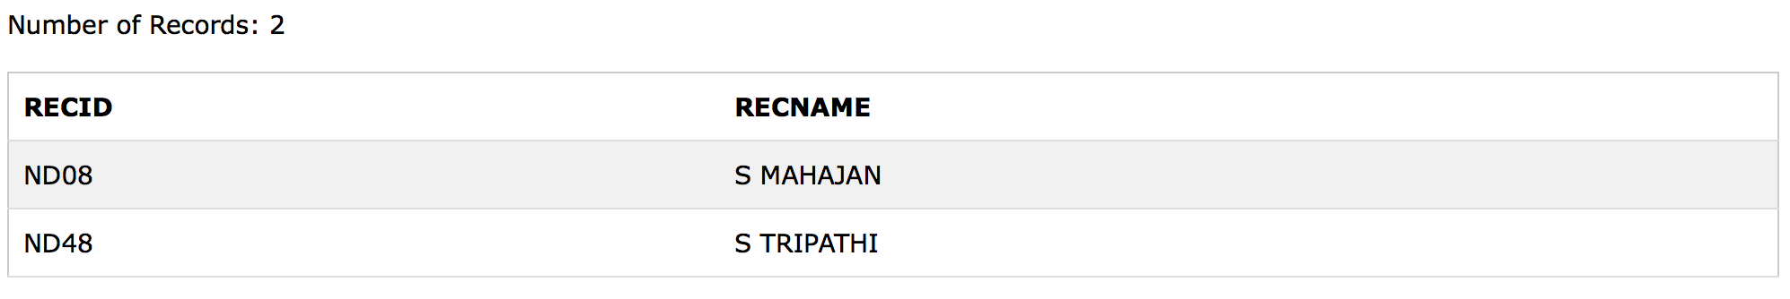

**QUESTION 4**

Consider the following tables. Write SQL commands for the statements (i) to (iv).

**TABLE : WORKER**

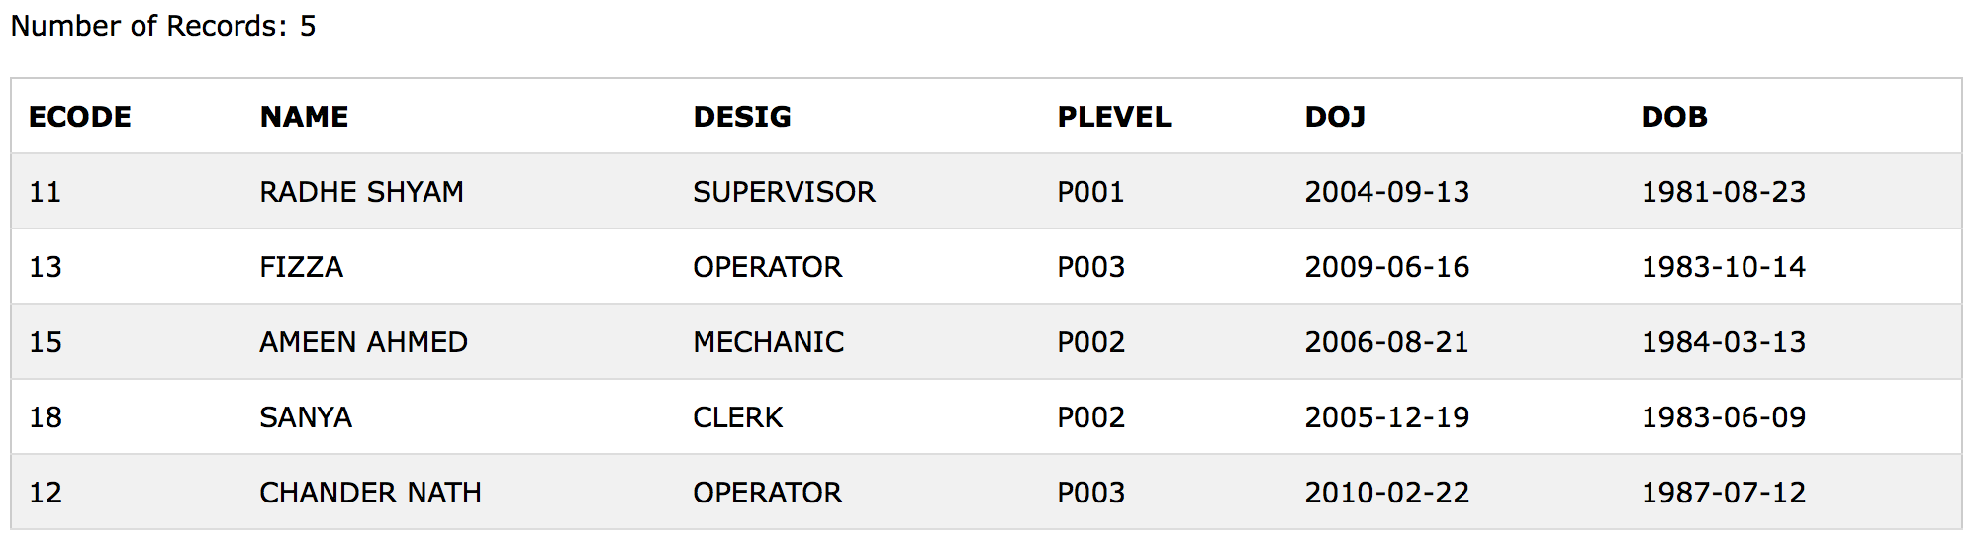**TABLE : PAYLEVEL**

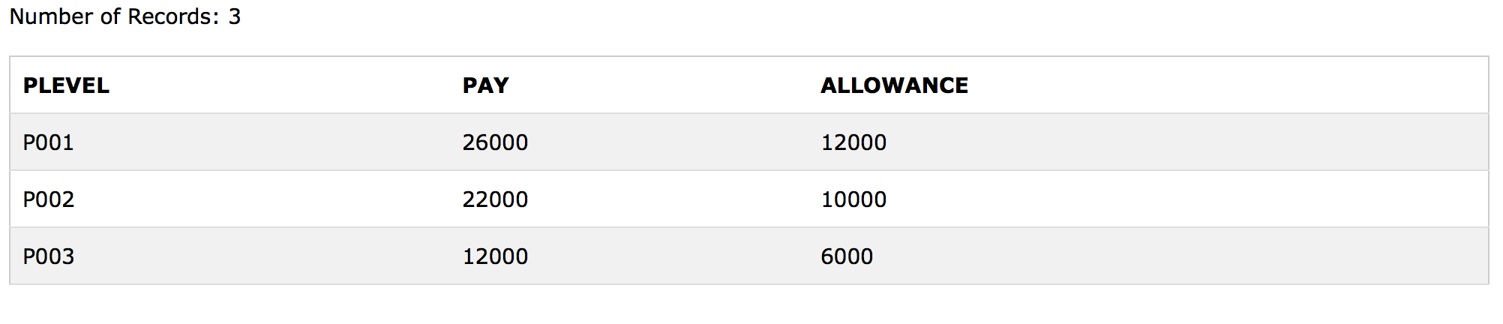

1. To display the details of all workers in descending order of DOB.
2. To display the name and designation of workers, whose pay level is either P001 or P002.
3. To display the content of all the workers table, whose DOB is between ’19 Jan 1984’ and ’18 Jan 1987’.
4. To add a new row with the following :

19, ‘Daya Kishore’, ‘Operator’, ‘P003’, ’19-Jun-2008’, ’11-Jul-1984’.

**CREATING TABLES**

**WORKERS**

CREATE TABLE WORKERS (ECODE INTEGER, NAME CHAR(30), DESIG CHAR(20), PLEVEL VARCHAR(10), DOJ DATETIME, DOB DATETIME);

INSERT INTO WORKERS VALUES (11, 'RADHE SHYAM', 'SUPERVISOR', 'P001', '2004-09-13', ‘1981-08-23');

INSERT INTO WORKERS VALUES (12, 'CHANDER NATH', 'OPERATOR', 'P003', '2010-02-22', ‘1987-07-12');

INSERT INTO WORKERS VALUES (13, 'FIZZA', 'OPERATOR', 'P003', '2009-06-16', ‘1983-10-14');

INSERT INTO WORKERS VALUES (15, 'AMEEN AHMED', 'MECHANIC', 'P002', '2006-08-21', ‘1984-03-13');

INSERT INTO WORKERS VALUES (18, 'SANYA', 'CLERK', 'P002', '2005-12-19', '1983-06-09');

**PAYLEVEL**

CREATE TABLE PAYLEVEL (PLEVEL VARCHAR(10), PAY INTEGER, ALLOWANCE INTEGER);

INSERT INTO PAYLEVEL VALUES ('P001', 26000, 12000);

INSERT INTO PAYLEVEL VALUES ('P002', 22000, 10000);

INSERT INTO PAYLEVEL VALUES ('P003', 12000, 6000);



**ANSWERS**

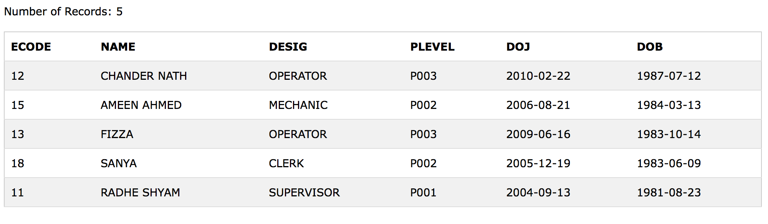

1. SELECT * FROM WORKERS ORDER BY DOB DESC;

ii) SELECT NAME, DESIG FROM WORKERS WHERE PLEVEL='P002' OR 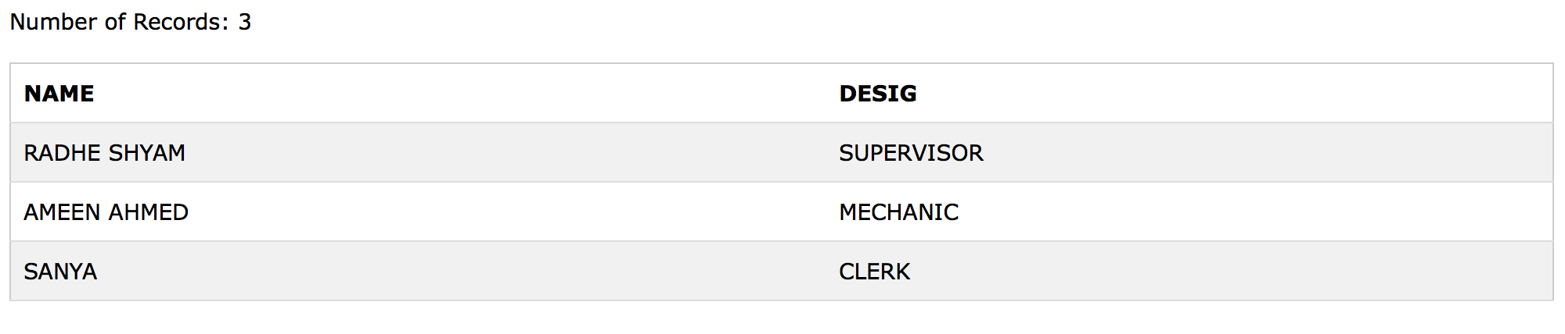PLEVEL=‘P001';

iii) SELECT * FROM WORKERS WHERE DOB BETWEEN '1984-01-19' AND 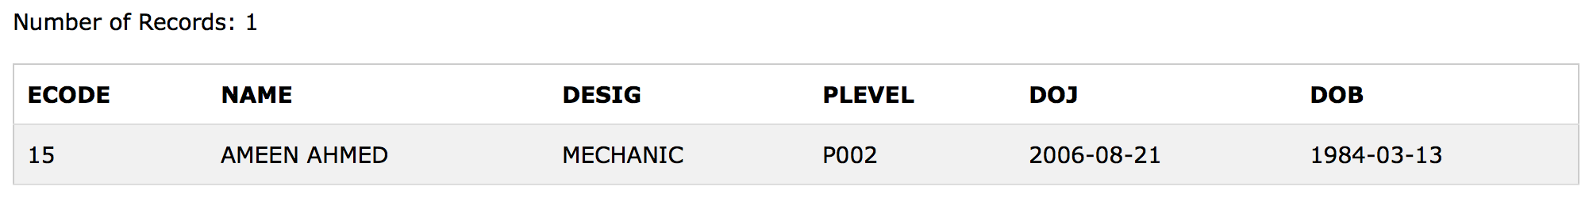‘1987-01-18'

iv) INSERT INTO WORKERS VALUES (19, 'DAYA KISHORE', 'OPERATOR', 'P003', '2008-06-19', ‘1984-07-11');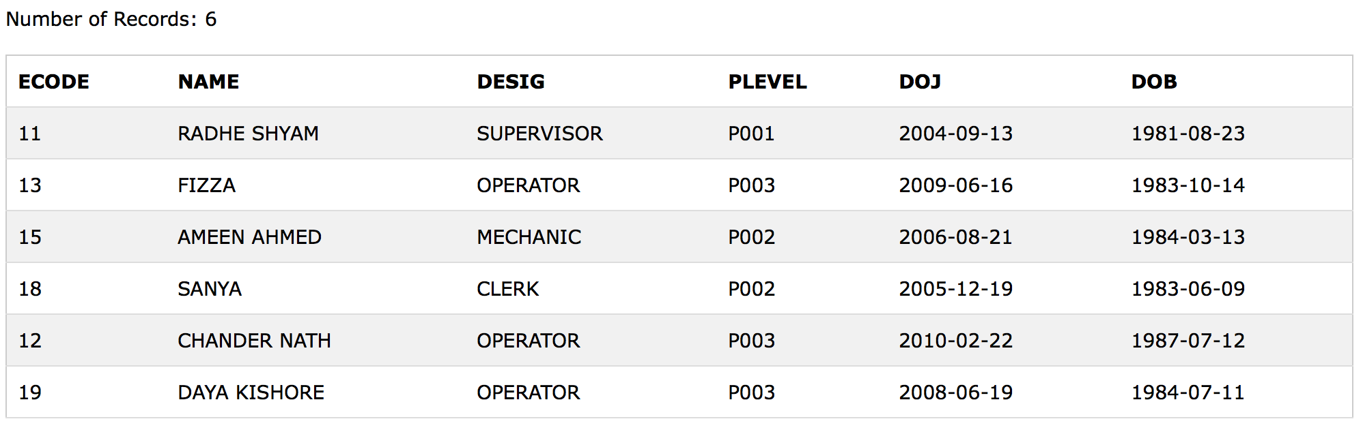

**QUESTION 5**

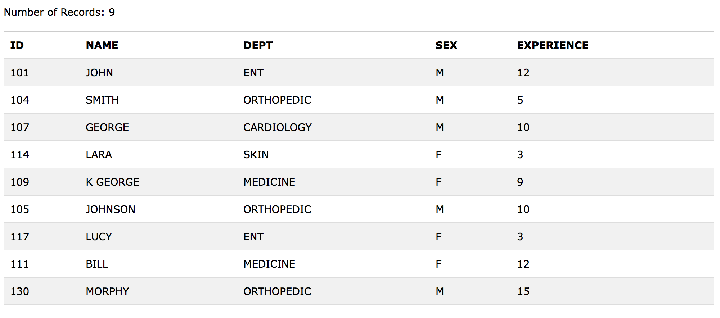Consider the following tables. Write SQL commands for the statement (i) to (iv).

**TABLE : DOCTOR**

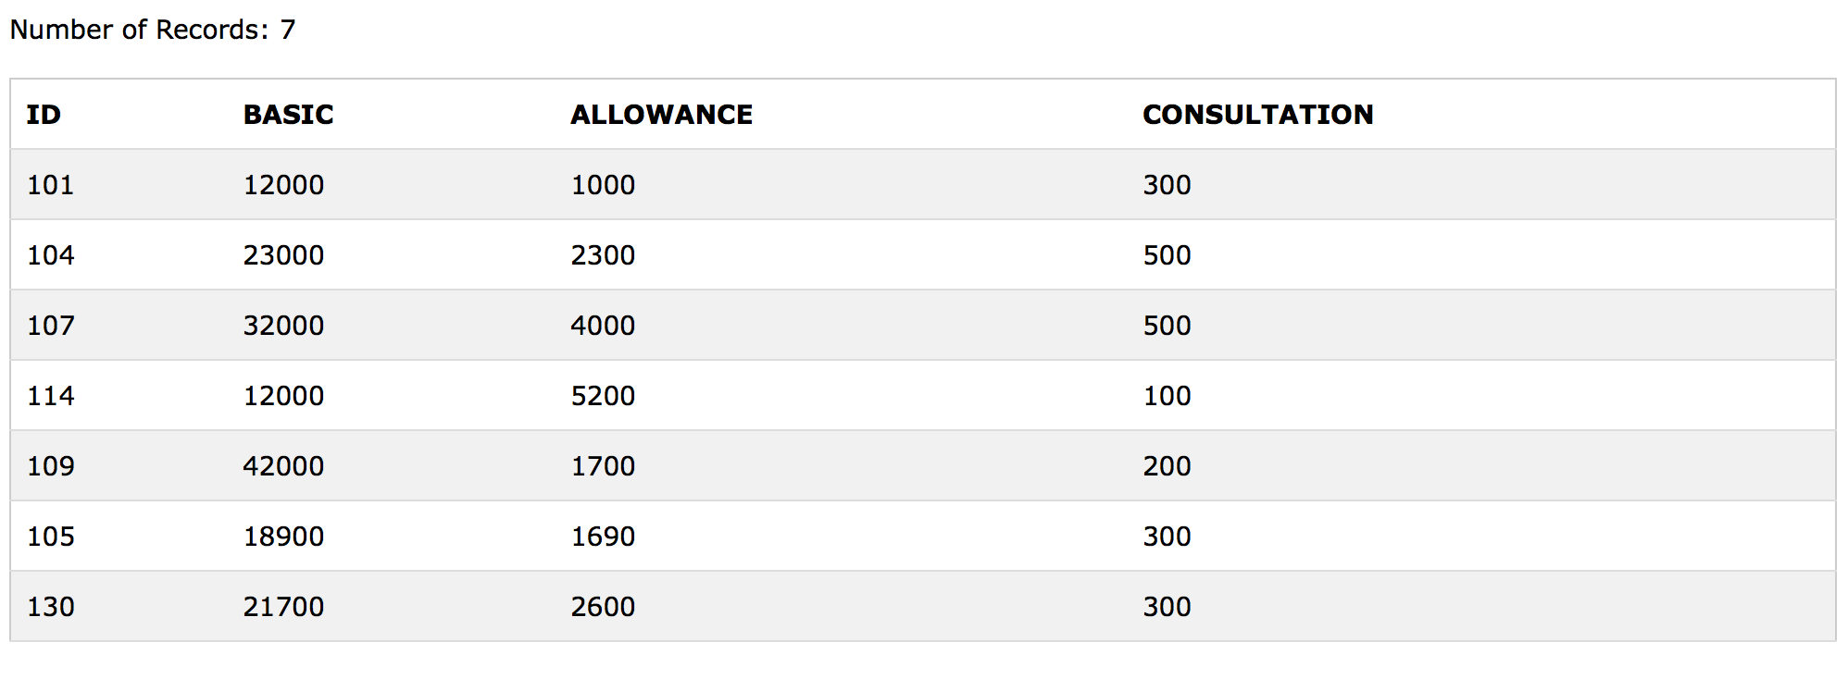**TABLE : SALARY**

1. To display the name of all doctors who are in medicine and having more than 10 years experience from the table doctor.
2. To display the average salary of all doctors working in ENT using the tables doctor and salary. Salary = basic + allowance.
3. To display the minimum allowance of female doctors.
4. To display the highest consultation fee among all male doctors.

**CREATING TABLES**

**DOCTOR**

CREATE TABLE DOCTOR (ID INTEGER, NAME CHAR(20), DEPT CHAR (20), SEX CHAR(1), EXPERIENCE INTEGER);

INSERT INTO DOCTOR VALUES (101, 'JOHN', 'ENT', 'M', 12);

INSERT INTO DOCTOR VALUES (104, 'SMITH', 'ORTHOPEDIC', 'M', 5);

INSERT INTO DOCTOR VALUES (107, 'GEORGE', 'CARDIOLOGY', 'M', 10);

INSERT INTO DOCTOR VALUES (114, 'LARA', 'SKIN', 'F', 3);

INSERT INTO DOCTOR VALUES (109, 'K GEORGE', 'MEDICINE', 'F', 9);

INSERT INTO DOCTOR VALUES (105, 'JOHNSON', 'ORTHOPEDIC', 'M', 10);

INSERT INTO DOCTOR VALUES (117, 'LUCY', 'ENT', 'F',3);

INSERT INTO DOCTOR VALUES (111, 'BILL', 'MEDICINE', 'F', 12);

****INSERT INTO DOCTOR VALUES (130, 'MORPHY', 'ORTHOPEDIC', 'M', 15);

**SALARY**

CREATE TABLE SALARY (ID INTEGER, BASIC INTEGER, ALLOWANCE INTEGER, CONSULTATION INTEGER);

INSERT INTO SALARY VALUES (101, 12000, 1000, 300);

INSERT INTO SALARY VALUES (104, 23000, 2300, 500);

INSERT INTO SALARY VALUES (107, 32000, 4000, 500);

INSERT INTO SALARY VALUES (114, 12000, 5200, 100);

INSERT INTO SALARY VALUES (109, 42000, 1700, 200);

INSERT INTO SALARY VALUES (105, 18900, 1690, 300);

INSERT INTO SALARY VALUES (130, 21700, 2600, 300);

**ANSWERS**

1. SELECT NAME FROM DOCTOR WHERE DEPT='MEDICINE' AND 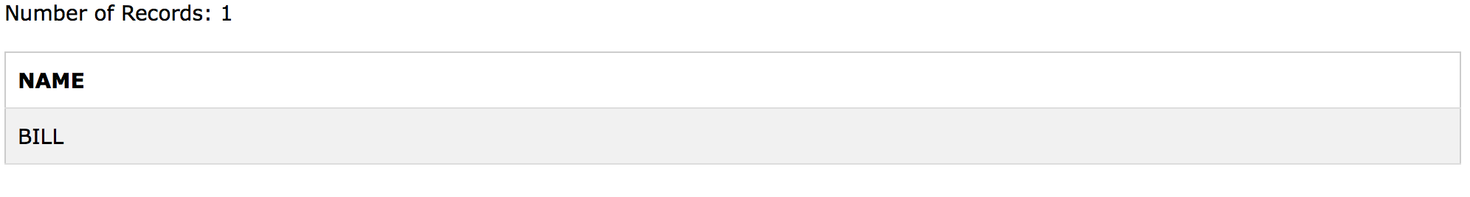EXPERIENCE>10;

ii) SELECT NAME, AVG(BASIC+ALLOWANCE) FROM SALARY, DOCTOR WHERE 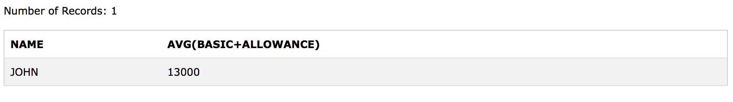SALARY.ID=DOCTOR.ID AND DEPT='ENT' GROUP BY SALARY.ID;

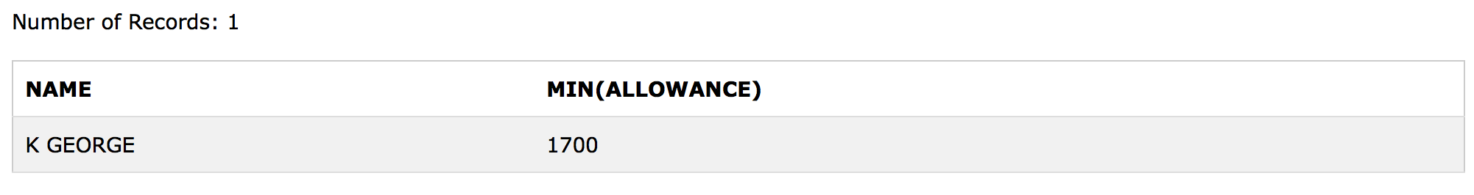iii) SELECT NAME, MIN(ALLOWANCE) FROM DOCTOR, SALARY WHERE SEX='F' AND SALARY.ID=DOCTOR.ID;

iv) SELECT NAME, MAX(CONSULTATION) FROM SALARY, DOCTOR WHERE SEX='M' AND SALARY.ID=DOCTOR.ID;

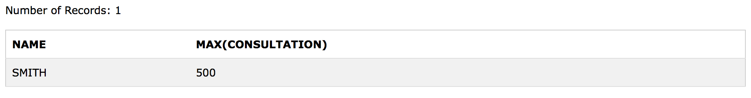

**QUESTION 6**

Consider the following tables. Write SQL commands for the statement (i) to (iv).

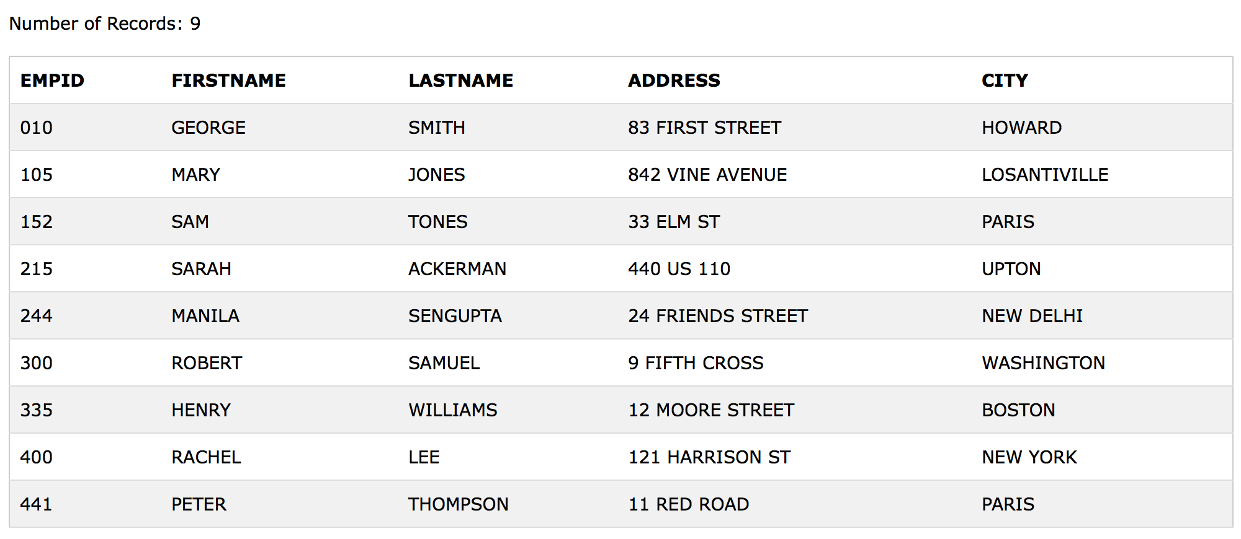**TABLE : EMPLOYEES**

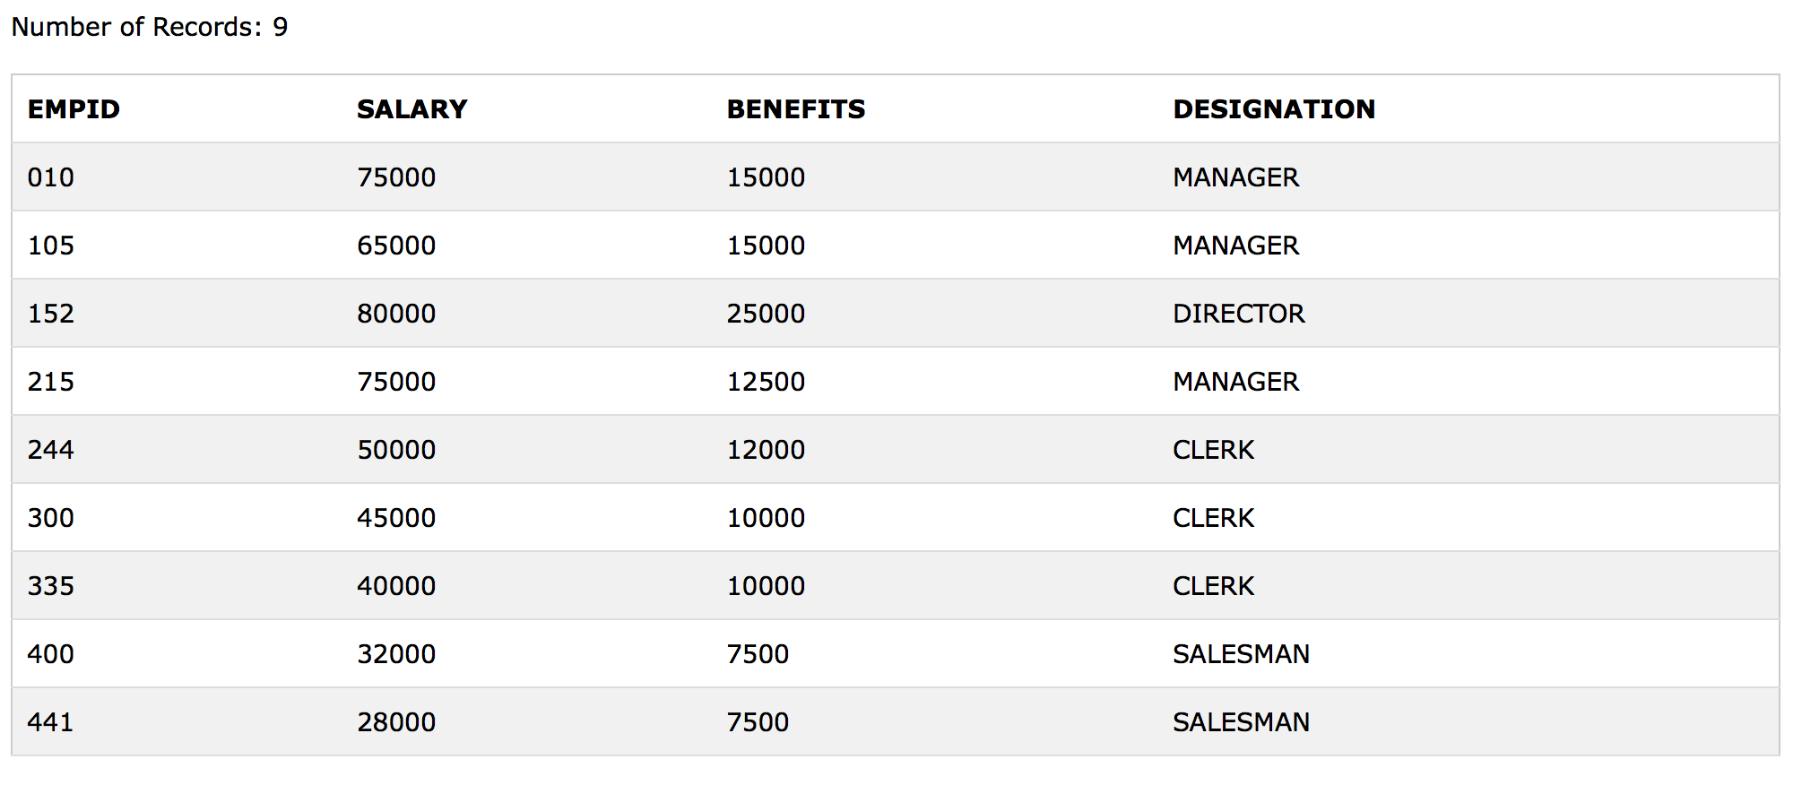**TABLE : EMPSALARY**

1. To display the first name, last name, address and city of all employees living in Paris.
2. To display the content of employees table in descending order of first name.
3. To display the first name, last name, and total salary of all managers from the tables employees and empsalary where total salary is salary is salary + benefits.
4. To display the maximum salary among managers and clerks.

**CREATING TABLES**

**EMPLOYEES**

CREATE TABLE EMPLOYEES (EMPID CHAR(5), FIRSTNAME CHAR(20), LASTNAME CHAR(20), ADDRESS VARCHAR(30), CITY CHAR(20));

INSERT INTO EMPLOYEES VALUES (‘010’, 'GEORGE', 'SMITH', '83 FIRST STREET', ‘HOWARD');

INSERT INTO EMPLOYEES VALUES ('105', 'MARY', 'JONES', '842 VINE AVENUE', 'LOSANTIVILLE');

INSERT INTO EMPLOYEES VALUES ('152', 'SAM', 'TONES', '33 ELM ST', 'PARIS');

INSERT INTO EMPLOYEES VALUES ('215', 'SARAH', 'ACKERMAN', '440 US 110', 'UPTON');

INSERT INTO EMPLOYEES VALUES ('244', 'MANILA', 'SENGUPTA', '24 FRIENDS STREET', 'NEW DELHI');

INSERT INTO EMPLOYEES VALUES ('300', 'ROBERT', 'SAMUEL', '9 FIFTH CROSS', 'WASHINGTON');

INSERT INTO EMPLOYEES VALUES ('335', 'HENRY', 'WILLIAMS', '12 MOORE STREET', 'BOSTON');

INSERT INTO EMPLOYEES VALUES ('400', 'RACHEL', 'LEE', '121 HARRISON ST', 'NEW YORK');

INSERT INTO EMPLOYEES VALUES ('441', 'PETER', 'THOMPSON', '11 RED ROAD', 'PARIS');



**EMPSALARY**

CREATE TABLE EMPSALARY (EMPID CHAR(5), SALARY INTEGER, BENEFITS INTEGER, DESIGNATION CHAR(20));

INSERT INTO EMPSALARY VALUES ('010', 75000, 15000, ‘MANAGER');

INSERT INTO EMPSALARY VALUES ('105', 65000, 15000, ‘MANAGER');

INSERT INTO EMPSALARY VALUES ('152', 80000, 25000, ‘DIRECTOR');

INSERT INTO EMPSALARY VALUES ('215', 75000, 12500, ‘MANAGER');

INSERT INTO EMPSALARY VALUES ('244', 50000, 12000, ‘CLERK');

INSERT INTO EMPSALARY VALUES ('300', 45000, 10000, ‘CLERK');

INSERT INTO EMPSALARY VALUES ('335', 40000, 10000, ‘CLERK');

INSERT INTO EMPSALARY VALUES ('400', 32000, 7500, ‘SALESMAN');

INSERT INTO EMPSALARY VALUES ('441', 28000, 7500, ‘SALESMAN');

**ANSWERS**

1. SELECT FIRSTNAME, LASTNAME, ADDRESS, CITY FROM 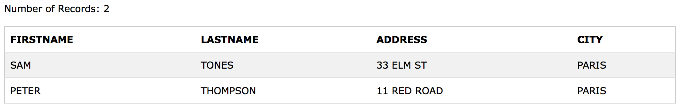EMPLOYEES WHERE CITY='PARIS';

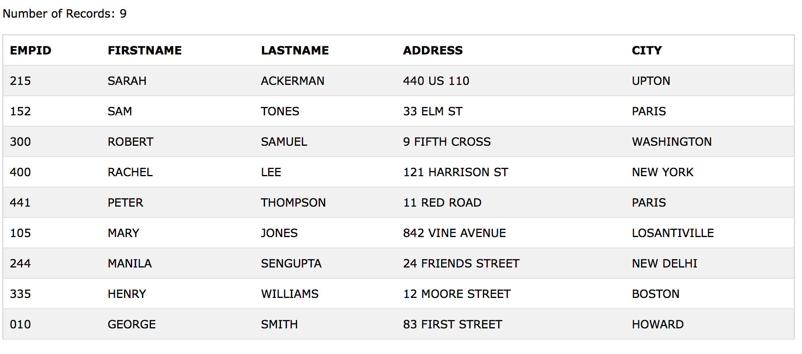

ii) SELECT * FROM EMPLOYEES ORDER BY FIRSTNAME DESC;

iii) SELECT FIRSTNAME, LASTNAME, SALARY+BENEFITS FROM EMPLOYEES, EMPSALARY WHERE EMPSALARY.EMPID=EMPLOYEES.EMPID AND 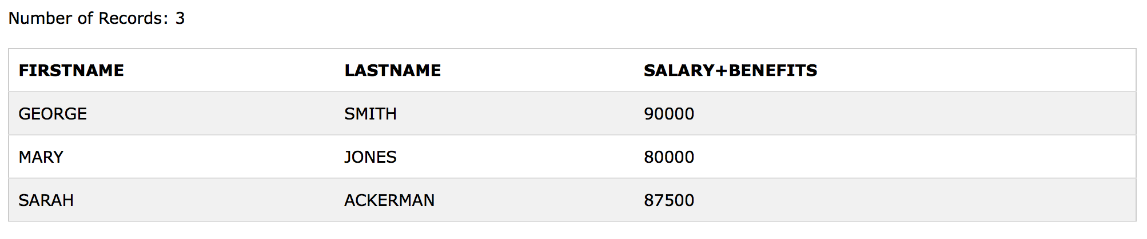DESIGNATION=‘MANAGER’;

iv) SELECT DESIGNATION, MAX(SALARY+BENEFITS) FROM EMPSALARY WHERE DESIGNATION='MANAGER' OR 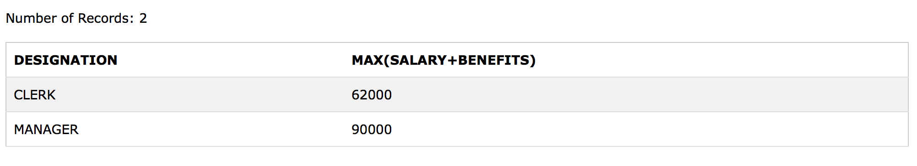DESIGNATION='CLERK' GROUP BY DESIGNATION;